

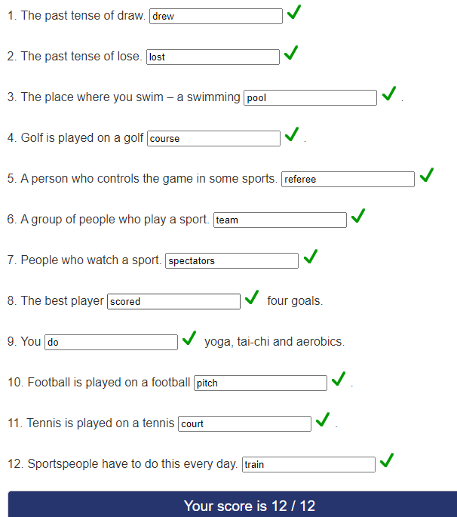

**Страница 10 упражнение 6**

**I like sport:**

1. I’m play football.
2. I've never won a trophy.
3. Yes, I got injured.
4. I like to play sports more.
5. I prefer to watch team sports.
6. No, I have little time for this.
7. Yes there is.
8. I would like to learn how to play volleyball.
9. I do not watch TV.

**Страница 11 упражнение 7**

**a**

**Muhammad Ali:** American professional boxer who competed in the heavyweight division; one of the most famous boxers in the history of world boxing. His debut in professional boxing took place on October 29, 1960, his rival was Tanny Hansecker. The cause of death of the former world boxing champion Muhammad Ali was septic shock due to "unknown natural causes."

**Franz Beckenbauer:** German footballer and coach who played as a center-back or midfielder. Since 1994 - President of FC Bavaria, since February 2002 - Chairman of the Board of FC Bavaria JSC.

**John McEnroe:** American professional tennis player, former number one in the world. In the first year of his professional career, McEnroe won the title in the Grand Slam singles tournament, beating his friend Vitas Gerulaitis 7-5, 6-3, 6-3 in the US Open final. After this victory, he finished third in the ATP rankings, behind Bjorn Borg and Jimmy Connors. Member of the International Tennis Hall of Fame since 1999.

**Michael Jordan:** American basketball player, former NBA player. He played as an attacking defender. Jordan was instrumental in popularizing basketball and the NBA around the world in the 1980s and 1990s. After starting a career with the University of North Carolina team (1982-1984) with which he won the 1982 NCAA Championship, Jordan joined the Chicago Bulls in 1984. For his phenomenal jumping ability, Michael received the nicknames "Air Jordan" and "His Air". Now, in the Forbes ranking, Michael Jordan is considered the wealthiest basketball player in the world. The fortune of the NBA champion at the rate for 2018 is $ 1.65 billion. The athlete's capital consists of those funds that were paid as salaries and bonuses, as well as in the form of income from work in advertising.

**b**

It is difficult for professional athletes to retire, as they are accustomed to fame, doing their favorite thing, and therefore many feel depressed after leaving.

**c**

1. F
2. E
3. C
4. B
5. A
6. D

**d**

1. glamour
2. loss
3. recognition
4. failure
5. retirement

**e**

**Roman Pavlyuchenko:** striker of the Yekaterinburg club "Ural", and one of the best players in the history of the Russian national team. From November 2002 to August 2008, Roman played for the football club Spartak (Moscow), and from August 2008 to February 2012 he played for the English Tottenham Hotspur. This transfer made him one of the most expensive Russian footballers sold abroad (the amount of compensation received by Spartak was at least 17 million euros). In February 2012, he signed a 3.5-year contract with Lokomotiv Moscow. However, Pavlyuchenko did not become a player of the main team. On July 24, 2013, Roman announced that he was ending his career in the national team. Now he is a member of the State Duma. I think he could have finished football a little later.